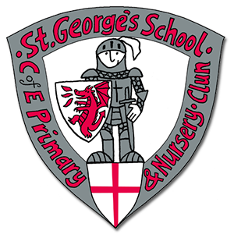
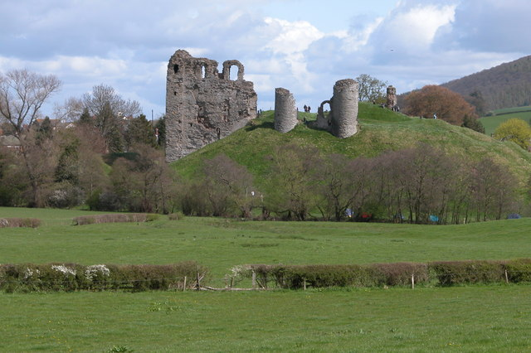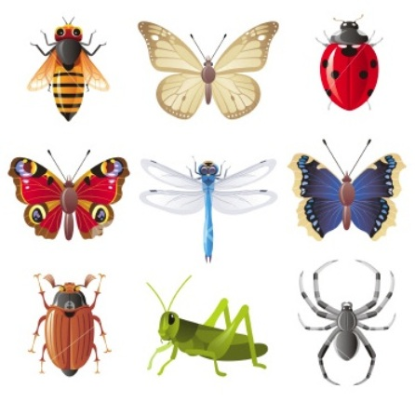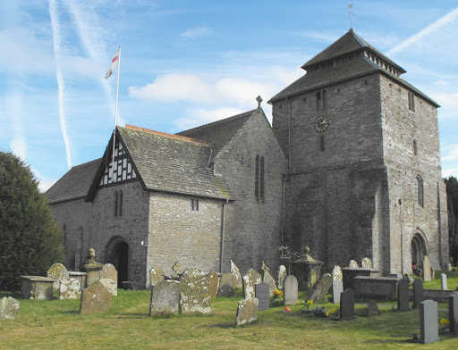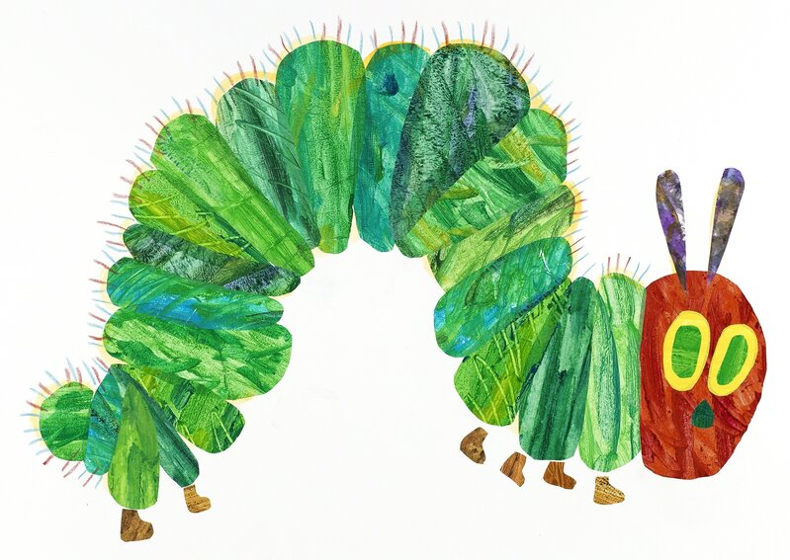
As scientists we will learn about:
Growing plants
Seasonal changes from Spring to Summer
Minibeasts
As artists we will consider:
creating landscapes based on features in Clun
.
,
In Physical Development, we will explore:
creating movements to represent minibeasts
ball skills
As historians we will learn about:
Clun castle
As geographers we will learn about:
Clun

As musicians we will learn about:
creating patterns of loud/quiet sounds
composing music to describe minibeasts
In RE we will be reflecting upon:
Special places
We will be celebrating
St George’s day, Pentecost

In Personal, Social and Emotional Development we will explore:
relationships, fair/unfair, sharing, resolving conflict and dealing with change
Our key texts this term are: The Very Hungry Caterpillar, Non-fiction text Caterpillars and Butterflies, Mad About Minibeasts

