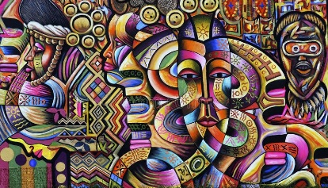
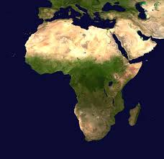
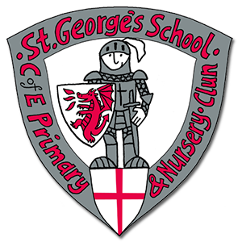

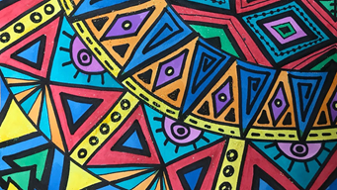
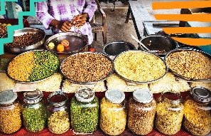
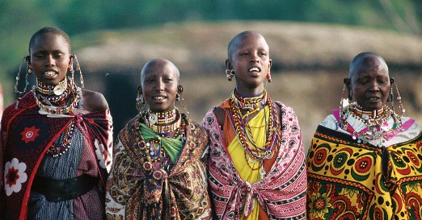
As scientists we will learn about:
Sound – exploring the anatomy of the ear, pitch, sound waves, vibrations.
Forces and magnets – exploring friction, magnets.
As Geographers we will learn about:
the geographical similarities and differences through studying the human and physical geography of the United Kingdom, and areas in Africa – specifically we are looking at Shropshire and Kenya.
As healthy citizens (PE Mental Health PSHE BV) we will learn about:
PE Rounders
PSHE RSE Changes
BV Respect
As musicians we will learn about:
Ukelele
As artists we will consider:
Storytelling through art. We will be thinking about how artists use art to tell stories, thinking about expressions and textures. We will be using clay to create our own art showcasing characters from our favourite books.

.
Our key texts this term are:
The Firework Makers Daughter, Why the Whales Came

