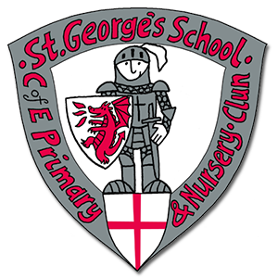
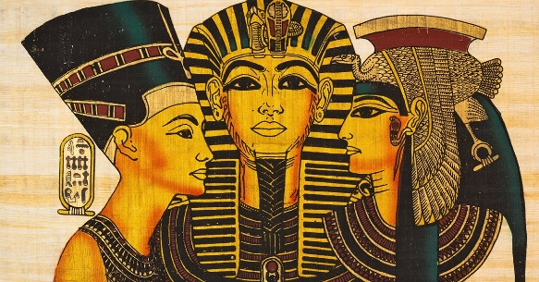
As artists we will consider:
Exploring storytelling through drawing. Thinking about how artists create sequenced drawings to share and tell stories. We will create comic strips to retell poetry.

As scientists we will learn about:
- Properties about the different rocks.
- Classifying rocks (igneous, sedimentary or metamorphic and this classification depends on the method of their formation.
- Rock particles and organic matter.
- Fossils and prehistoric animals.

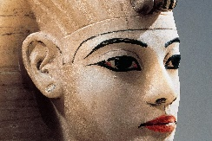
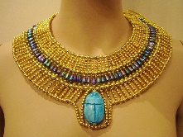
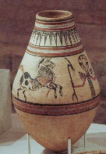
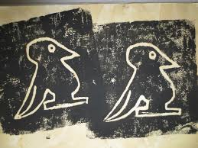
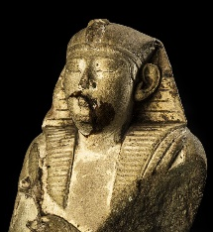
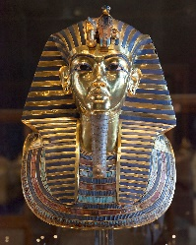
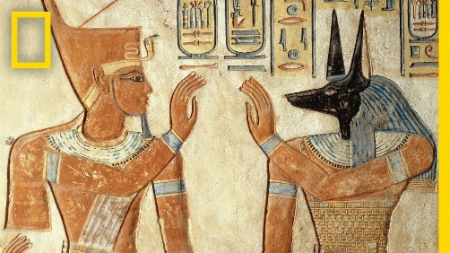
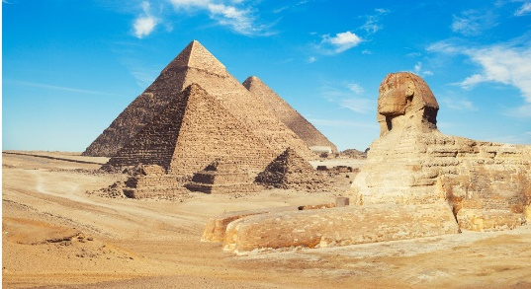
As Historians we will learn about:
How the ancient Egyptians lived 5000 years ago. We will explore the achievements of one of the earliest civilizations.
As design technologists we will learn about:
Dips – exploring basic food preparation. Students learn safe knife skills, food hygiene, and how to evaluate and design food products.
As Geographers we will learn about:
Where Egypt is located in the world, how the ancient Egyptians shaped the way it looks today and the key environmental factors which contributed to success of the ancient Egyptians.
As musicians we will learn about:
Ukelele
Our key texts this term are:
There’s a Pharaoh in Our Bath! by JeremyStrong, Iron Man by Ted Hughes, The Sheep Pig
.

As healthy citizens (PE Mental Health PSHE BV) we will learn about:
PE Multiskills, Dance and Football
PSHE Being Me in my World
BV Rule of Law

